**WEBSITE TRAFFIC ANALYSIS**

## OBJECTIVE :

The primary objective of website traffic analysis is to gain comprehensive insights into the performance and user behavior of your online platform. This multifaceted analysis encompasses various aspects, starting with measuring the volume of incoming visitors over a specific timeframe. It delves deeper to uncover critical demographic information about your audience, including age, gender, location, and interests. Additionally, traffic analysis allows you to pinpoint the sources of your website traffic, be it through search engines, social media, referrals, or direct visits. It enables you to understand how users navigate through your site, identifying popular pages, average time spent on each page, and user navigation paths. Furthermore, it provides the means to track and optimize conversions, monitor bounce rates, and assess the effectiveness of calls to action and links. By analyzing performance in SEO rankings, content popularity, mobile versus desktop traffic, and other factors, you can make informed decisions to enhance your website's functionality and meet your goals, whether they revolve around sales, lead generation, or information dissemination. Regular traffic analysis facilitates ongoing improvements, informs A/B testing, and supports data- driven decision-making to ensure your website remains a dynamic and successful online presence.

## DATA VISUALIZATION :

IBM Cognos Analytics offers a variety of data visualization options, including charts, graphs, maps, and dashboards. This allows you to present your website traffic data in a visually appealing and easy-to-understand way.

## Some of the most common data visualizations used for website traffic analysis include:

* Line charts: Line charts are useful for tracking trends over time. For example, you could use a line chart to track your website's overall traffic, traffic from specific sources, or traffic to specific pages.

*Bar charts: Bar charts are useful for comparing different categories of data. For example, you could use a bar chart to compare traffic from different search engines, traffic from different social media platforms, or traffic from different marketing campaigns.

*Pie charts: Pie charts are useful for showing the distribution of data. For example, you could use a pie chart to show the percentage of traffic that comes from different sources, the percentage of traffic that goes to different pages, or the percentage of traffic that converts into leads or sales.

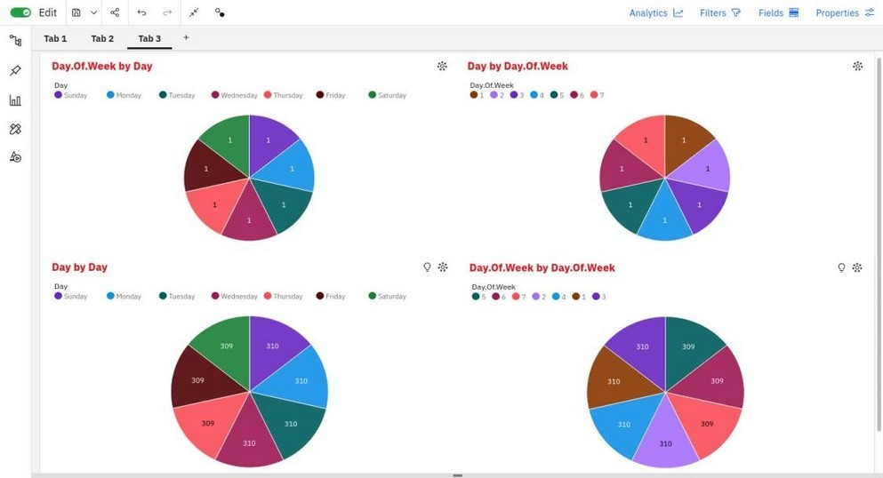 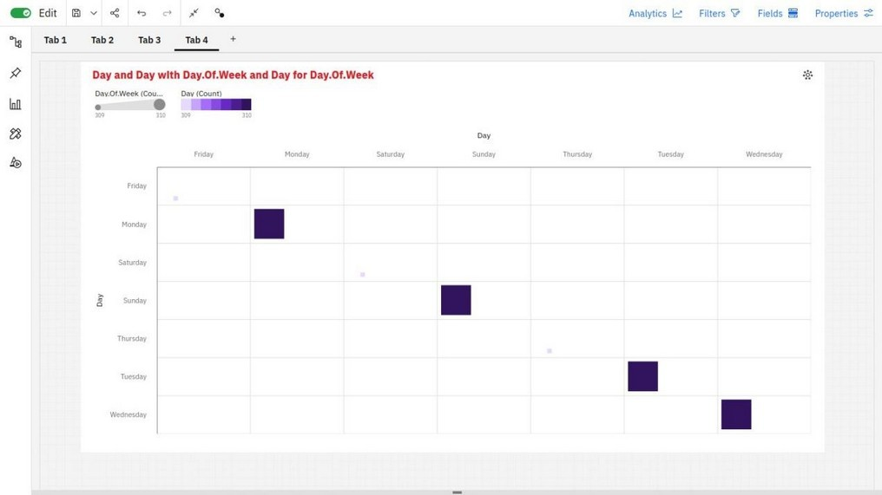

DATA VISUALIZATION OF PIE CAHRT DATA VISUALIZATION OF HEAT MAP

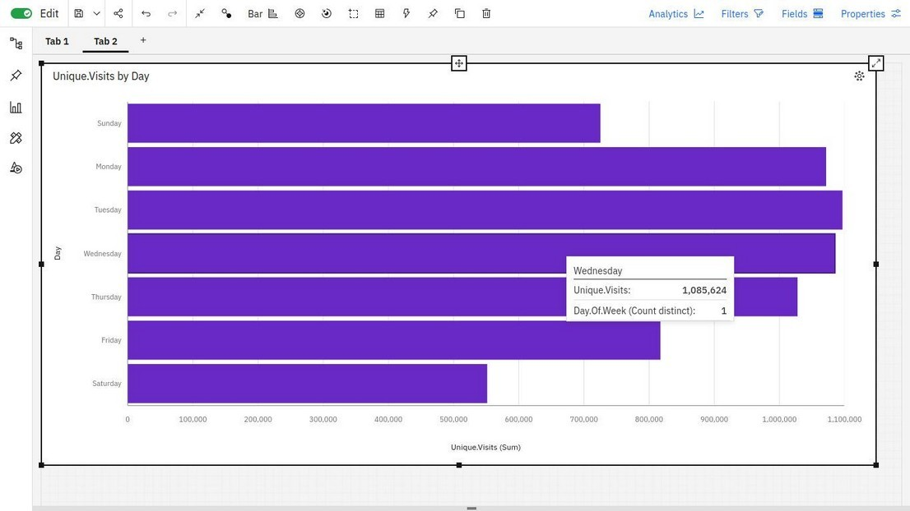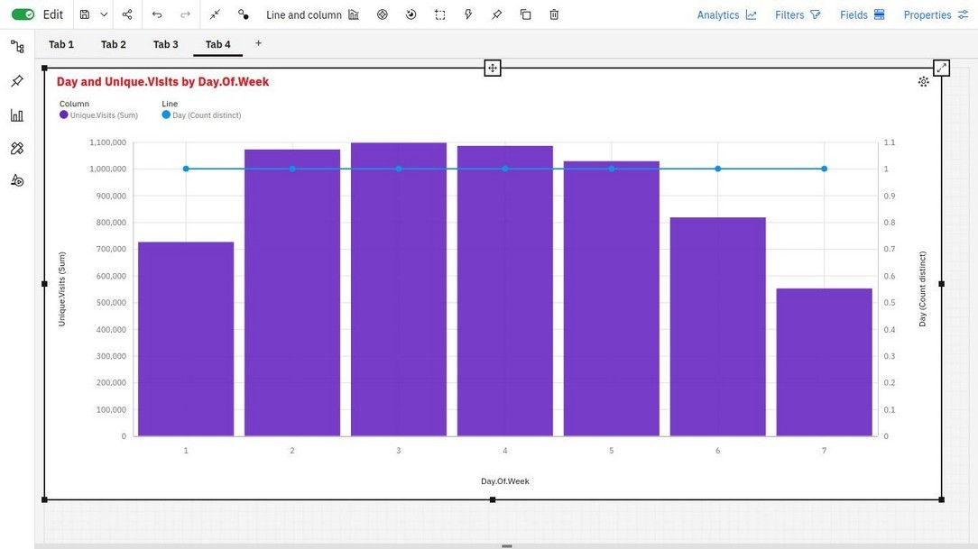

DATA VISUALIZATION OF BAR CHART DATA VISUALIZATION OF LINE

Heatmaps:

Heatmaps are useful for visualizing the density of data on a map or other image. For example, you could use a heatmap to visualize the geographic distribution of your website's traffic, or the most popular areas of a specific page.

Dashboards:

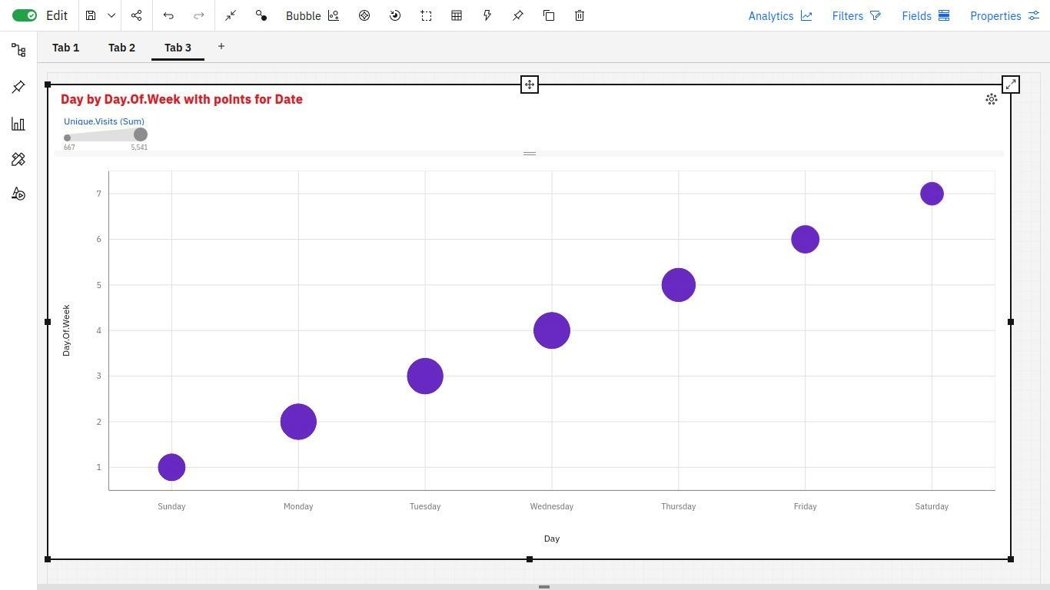Dashboards allow you to combine multiple data visualizations into a single view. This allows you to see all of your most important website traffic metrics at a glance.

# I.Visualising data with respect to worked for Day of Week by Day using Summary Map representation:

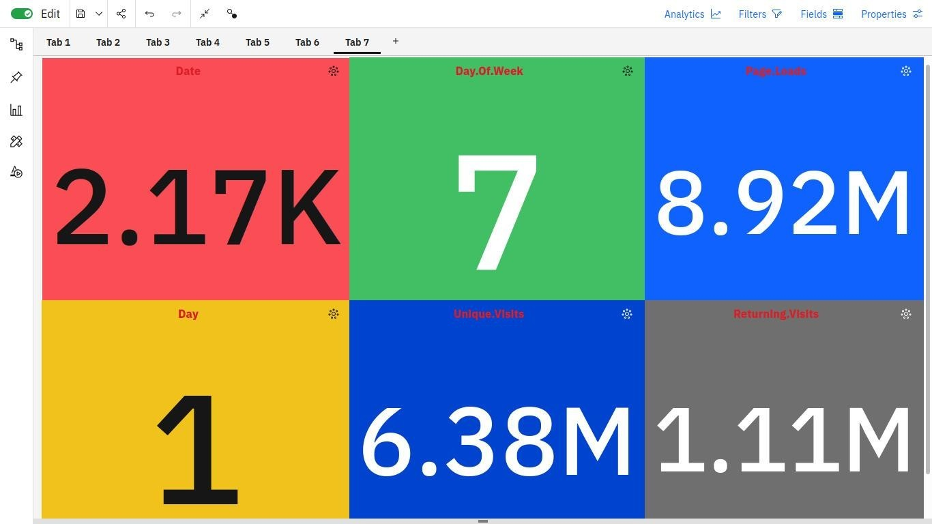

**DATA PROCESSING :**

Before you can analyze your website traffic data in IBM Cognos Analytics, you need to process it. This involves cleaning the data, transforming it into a format that is compatible with IBM Cognos Analytics, and loading it into the IBM Cognos Analytics data warehouse.

# Here is a general overview of the data processing procedure: Clean the data:

This involves removing any errors or inconsistencies from the data. For example, you may need to remove duplicate records, correct typos, or standardize the format of the data.

# Transform the data:

This involves converting the data into a format that is compatible with IBM Cognos Analytics. For example, you may need to convert the data to a different data type, or you may need to create new fields.

# Load the data:

This involves loading the processed data into the IBM Cognos Analytics data warehouse.

# Data Setup

Once you have processed your website traffic data, you need to set it up in IBM Cognos Analytics. This involves creating dimensions, measures, and facts.

# Dimensions:

Dimensions are the categories that you want to analyze your data by. For example, you could create a dimension for geographic location, a dimension for device type, or a dimension for traffic source.

# Measures:

Measures are the quantitative values that you want to measure. For example, you could create a measure for page views, unique visitors, or conversion rate.

# Facts:

Facts are the intersection of dimensions and measures. For example, you could create a fact for page views by geographic location, page views by device type, or page views by traffic source.

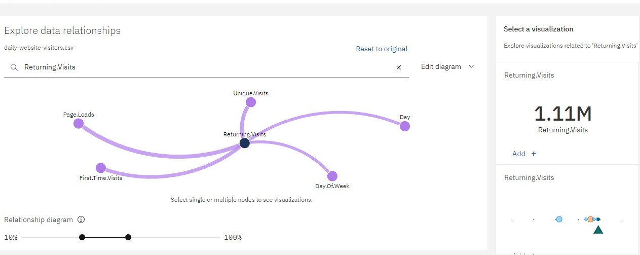

**Analysis Techniques :**

Once you have set up your website traffic data in IBM Cognos Analytics, you can start to analyze it. There are a variety of analysis techniques that we used the jupyter notebook as python complier with python library PANDAS which is used for data analysis.

# Here are some examples of analysis techniques that you can use for website traffic analysis:

**Trend analysis:**

Trend analysis involves looking at how your website traffic has changed over time. This can help you to identify trends that you may want to investigate further. For example, you may notice that your website traffic is increasing or decreasing, or that traffic from a particular source is increasing or decreasing.

# Segment analysis:

Segment analysis involves dividing your website traffic into different segments based on certain criteria, such as geographic location, device type, or traffic source. This can help you to understand the different types of visitors that are coming to your website and how they are interacting with your website. For example, you may want to segment your traffic by geographic location to see which countries are sending you the most traffic.

# Conversion analysis:

Conversion analysis involves tracking how your website visitors are interacting with your website and how they are converting into leads or sales. This can help you to identify areas where you can improve your website's performance. For example, you may want to track how many visitors are abandoning their shopping carts or how many visitors are signing up for your email list.

# Time Series Analysis:

Analyze time series data for trends, seasonality, and anomalies. Libraries like Pandas and Statsmodels are handy for this purpose.

# Descriptive Statistics:

Use Jupyter Notebook to calculate and visualize descriptive statistics like mean, median, variance, and standard deviation. Libraries like Pandas and Matplotlib can be helpful for this.

# Data Cleaning and Preprocessing:

Jupyter Notebook allows you to load, clean, and preprocess data using libraries such as Pandas and NumPy. You can remove missing values, handle outliers, and transform data as needed.

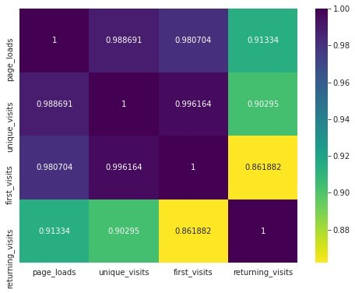

CONCLUSION :

In conclusion, this page has provided a comprehensive overview of the essential elements of data analysis, highlighting its significance in deriving valuable insights and making informed decisions. We explored various data analysis techniques and the role of Jupyter Notebook as a versatile tool for implementing these techniques. From data cleaning and visualization to advanced statistical analysis, machine learning, and deep learning, data analysis offers a diverse set of tools and methods to uncover patterns, trends, and relationships within datasets. Whether you're a data scientist, analyst, or anyone seeking to harness the power of data, understanding and applying these techniques in Jupyter Notebook can empower you to extract meaningful information from your data, inform strategic choices, and drive innovation. As the world becomes increasingly data-driven, mastering the art of data analysis is a crucial skill, and Jupyter Notebook serves as a valuable platform for this endeavor, fostering collaboration and reproducibility in the analytical process.